20

MODEL RESUME
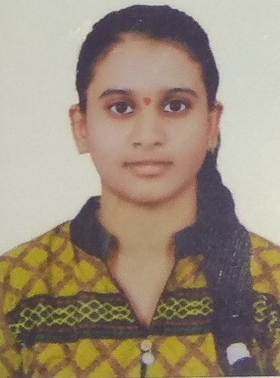

NAME : VENKATA NAGA SAROJA DEVARAKONDA
Phone : 7995490685
E-mail : sarojadevarakonda1704@gmail.com

CAREER OBJECTIVE
To obtain a challenging position as a Software Engineer in a leading multi-national organization where I can use my qualifications and skills to prove my abilities.

EDUCATIONAL QUALIFICATIONS
S.  No. | Examination  Passed | Name of Institute/  University | Discipline/  Subject | Month  & Year of  Passing | Percentage of  Marks | Division
1. | B. Tech | ACE Engineering, College  Hyderabad | Computer Science and Engineering (AIML) | Nov 2025 | 75 | Distn.
2. | Intermediate | Board of Inter Education T.S., Hyderabad | Maths,  Physics,  Chemistry. | March  2021 | 86 | First
3. | ICSE | Sri Sai Public School  Hyderaad | Maths,  Science,  Social Studies | March  2019 | 70 | First

TECHNICAL PROFILE
- Operating Systems : MS-DOS, Windows 2000 & XP.
- Languages : C , Python ,Java

ACHIEVEMENTS
- Got A2 Certificate in Cambridge Assesment
- Certified in Cisco C and Python
- Certified in Salesforce Internship program
- Certified in RPA

STRENGTHS
- Positive Attitude
- Determination
- Team Management
- Patience

WEAKNESSES
- Have a difficulty in saying NO
- Being particular about perfection

HOBBIES
- Interest in learning languages
- Listening to Music
- Watching movies

PERSONAL PROFILE
Date of Birth : 17th April 2004

Languages known : English, Telugu, Tamil

Father's Name : Mr. Ramesh Devarakonda

Mother’s Name : Mrs. Kanaka Durga Devarakonda

Address : H-No -3-18-220
Pragathi Nagar , Ramanthapur ,
Hyderabad

DECLARATION :

It is hereby acknowledged that the information furnished above is true to my knowledge.

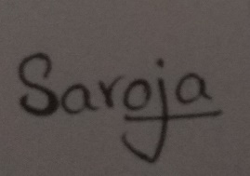
Place : Hyderabad Signature
Date : 08/11/2023
* * *

